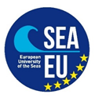

SEA-EU 2020 PHOTO COMPETITION “The Sea and Us”
Students' application

Name and surname:
Email address:
University component where you study:
Did you send the photos via Jumbo mail or are they attached to the email along with your application (mark the answer in the right part of this table)? | ☐ Yes, I sent them via Jumbo mail  ☐ Photos are attached to this email
Did you read the Tender and do you agree with all the terms (mark your answer)? | ☐ I read the tender and agree with the terms.

* Note: all submitted photos should be stored according to the principle: UNIST_NAME_SURNAME_Number of photo

